**Create the Logic App to send alerts when negative sentiments are received**

**High Level Overview of the solution**

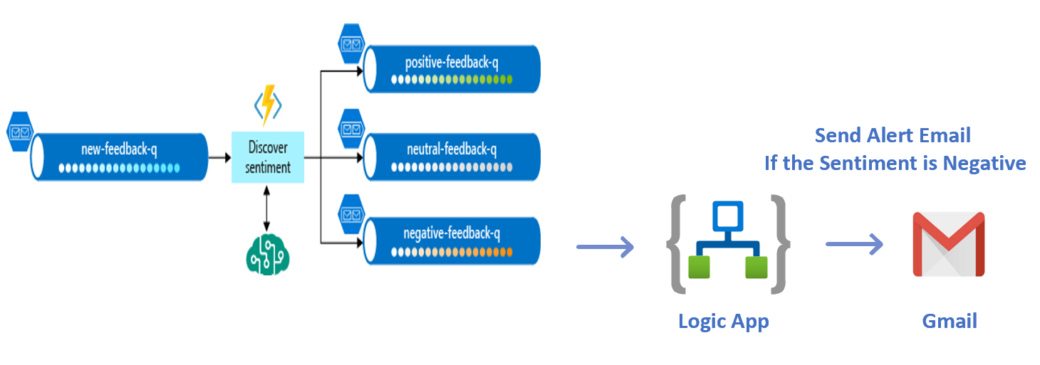

1. In the [Azure portal](https://portal.azure.com/), create an empty logic app by following the instructions in [Create your logic app](https://docs.microsoft.com/en-us/azure/logic-apps/quickstart-create-first-logic-app-workflow#create-your-logic-app). When you see the **Logic Apps Designer**, return to this tutorial.
2. In the splash page for Logic Apps Designer, select **When an HTTP request is received** under **Start with a common trigger**.

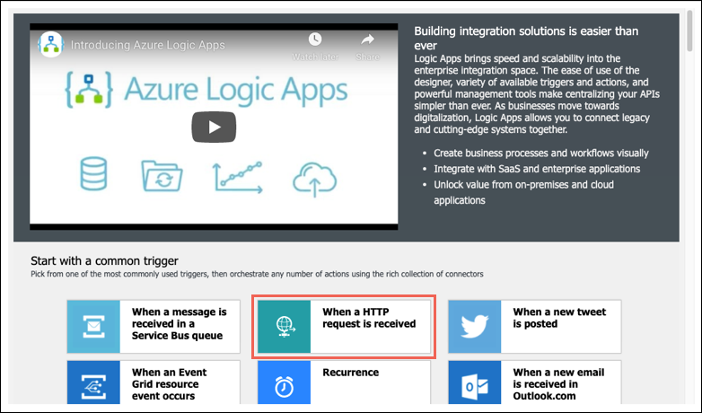

1. Click on Add new parameter and select Method option.

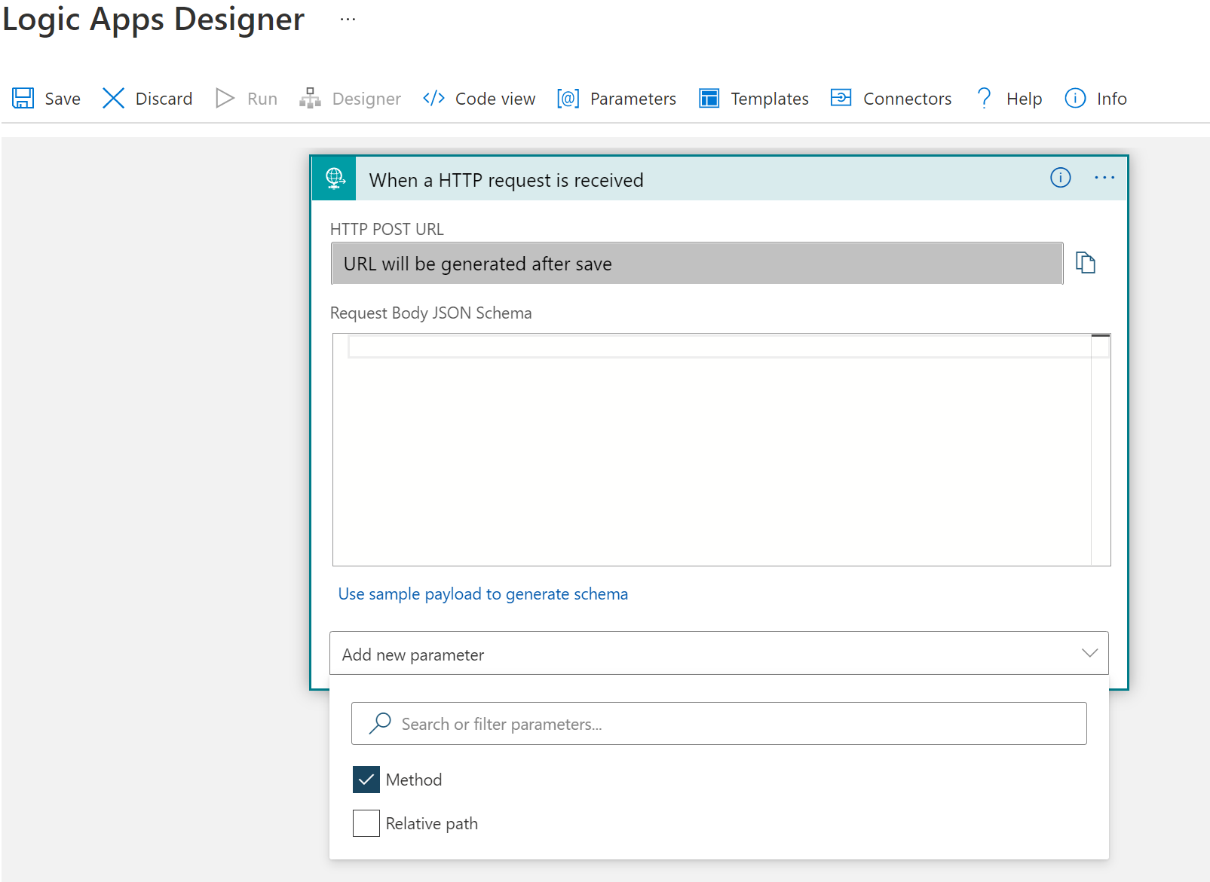

1. Select the Method as POST.

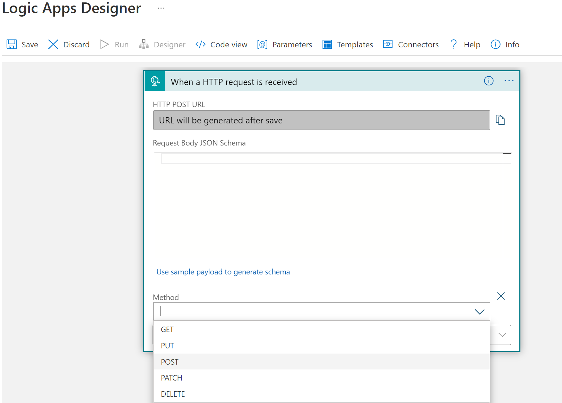

1. Save the logic app to complete the HTTP POST request method setup.

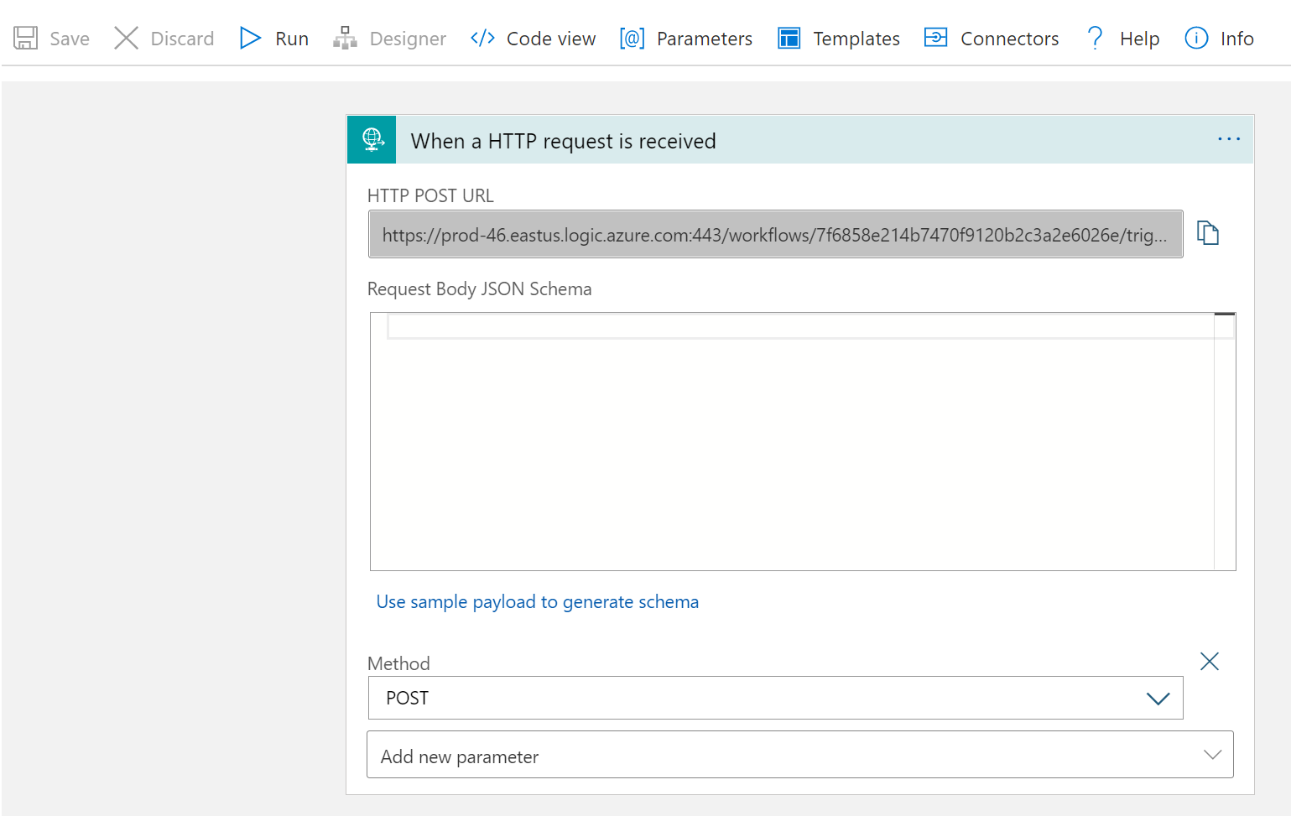

Make a note of the HTTP POST URL

Example:

<https://prod-78.eastus.logic.azure.com:443/workflows/947cc849f439437a923bdb6914ef4ed0/triggers/manual/paths/invoke?api->version=2016-10-01&sp=%2Ftriggers%2Fmanual%2Frun&sv=1.0&sig=ymIutpGGLYrRxuocT1hvGqxB-uyAEjQJCQ_DKNM_s3c

1. At the bottom of the designer, click New step, type Gmail in the actions search box and find and select Send email (V2).



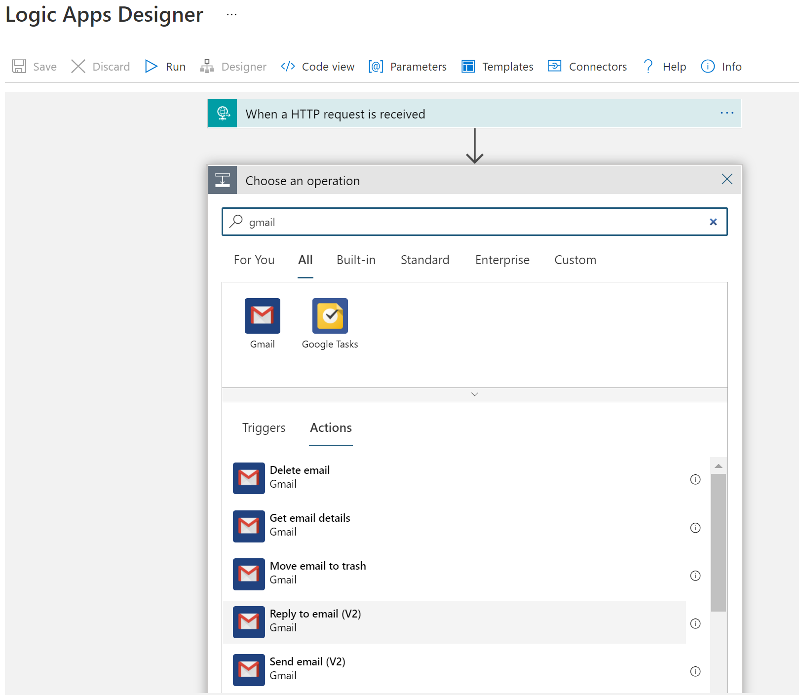

1. click on the Add new Parameter box and select the Subject option.

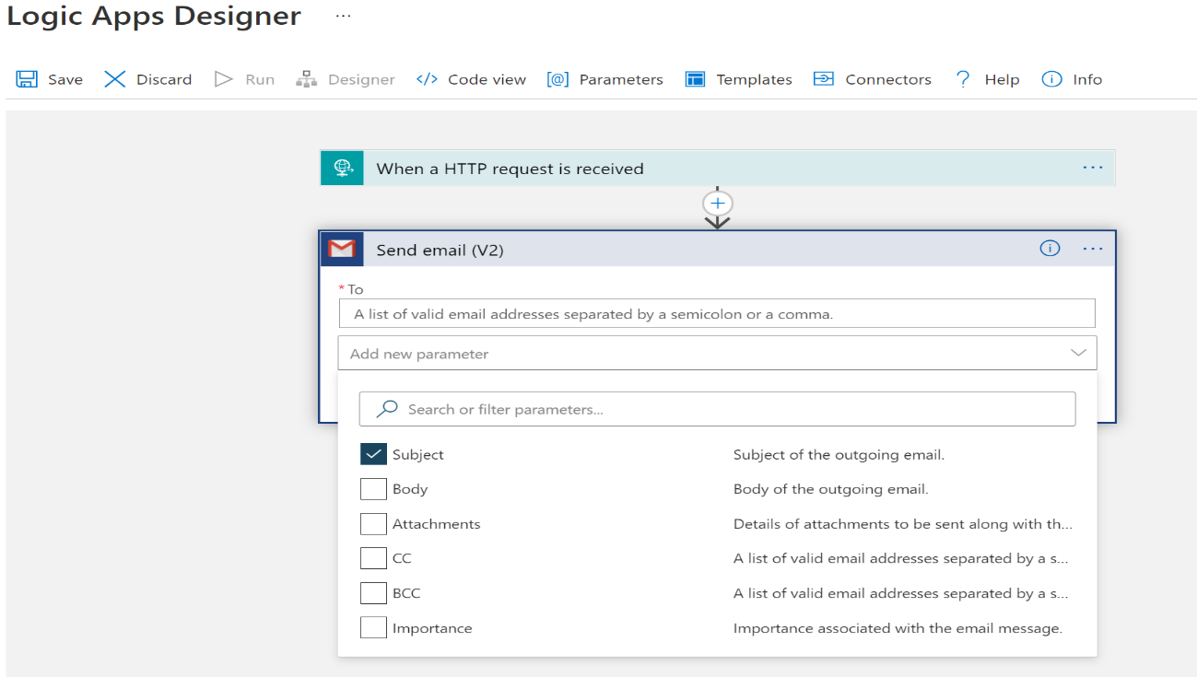

1. Click on the Subject textbox, and the Expression content dialog is automatically opened. Search for “triggerBody()” expression and click OK.

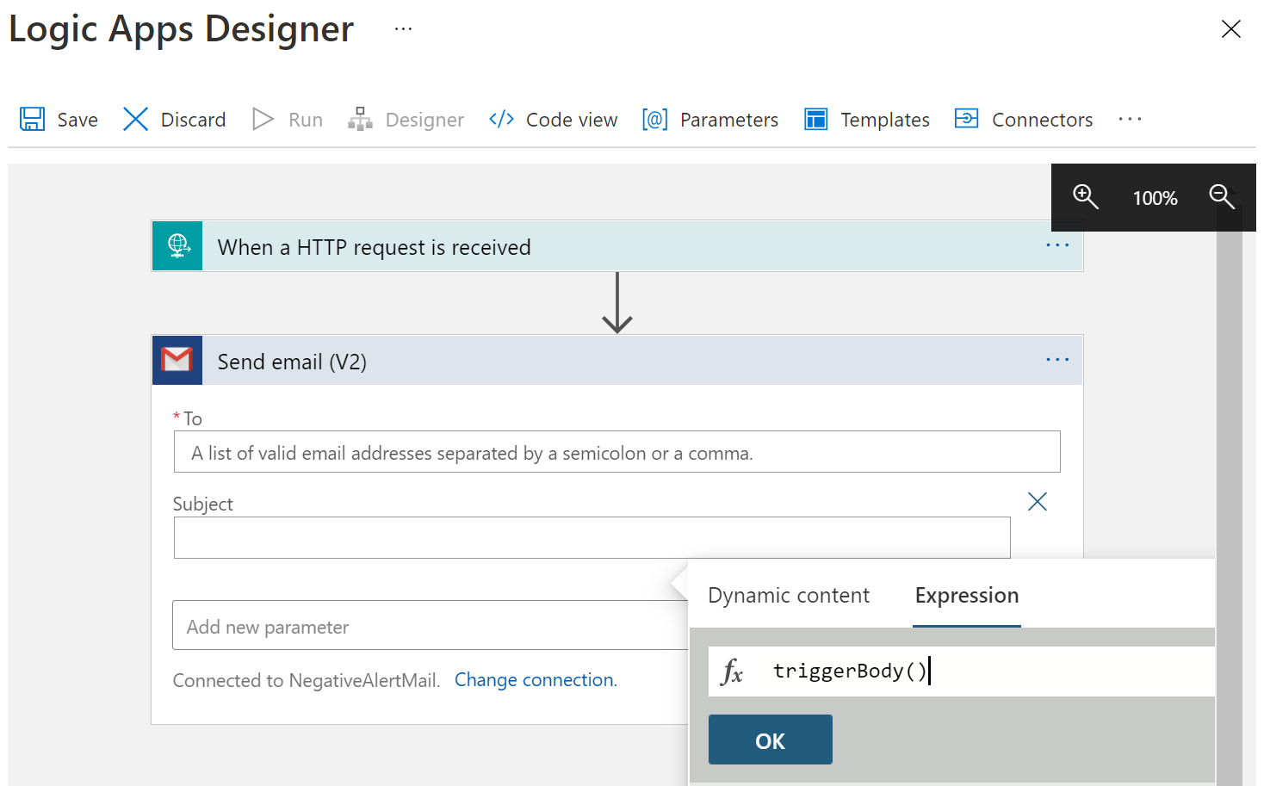

1. Save the logic app to complete the email setup.

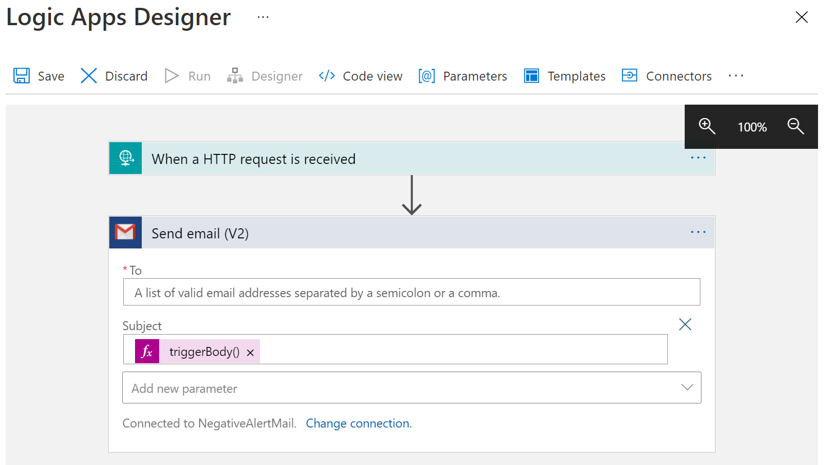

1. Go to your function app.

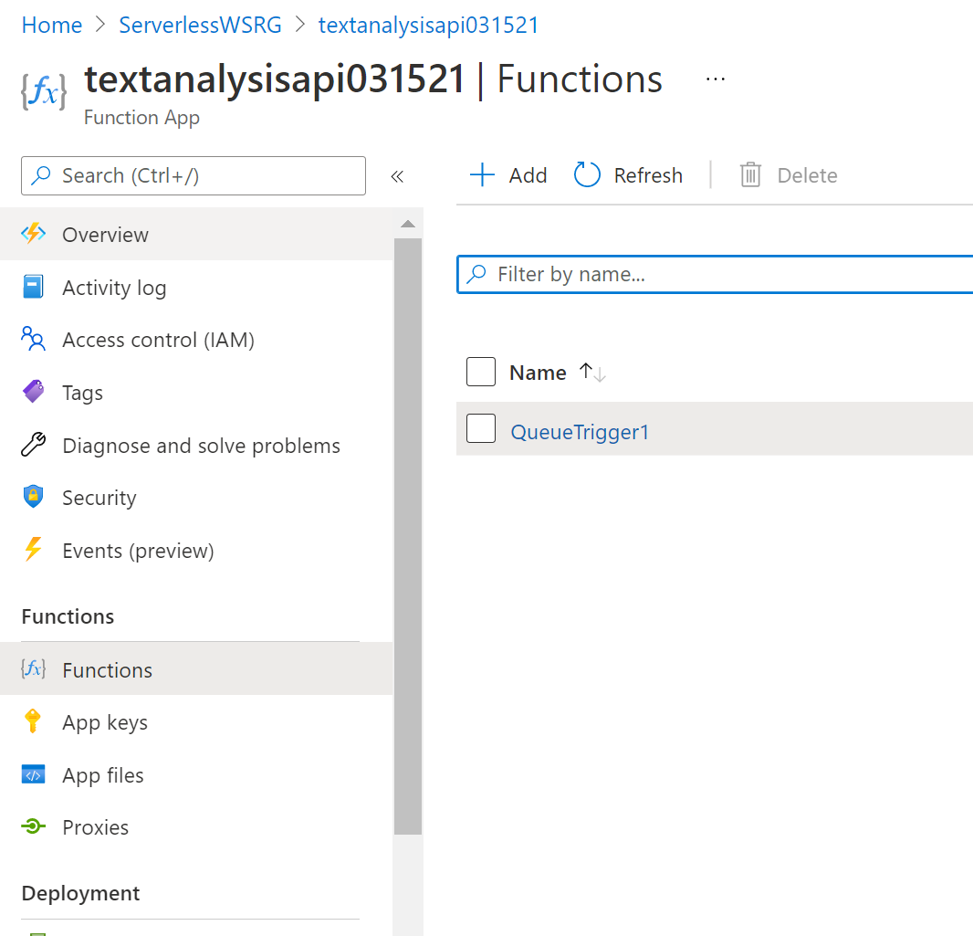

1. Open the Code editor and paste the logic to send negative sentiment email alert under **“else if (score < 0.3 )”** block.

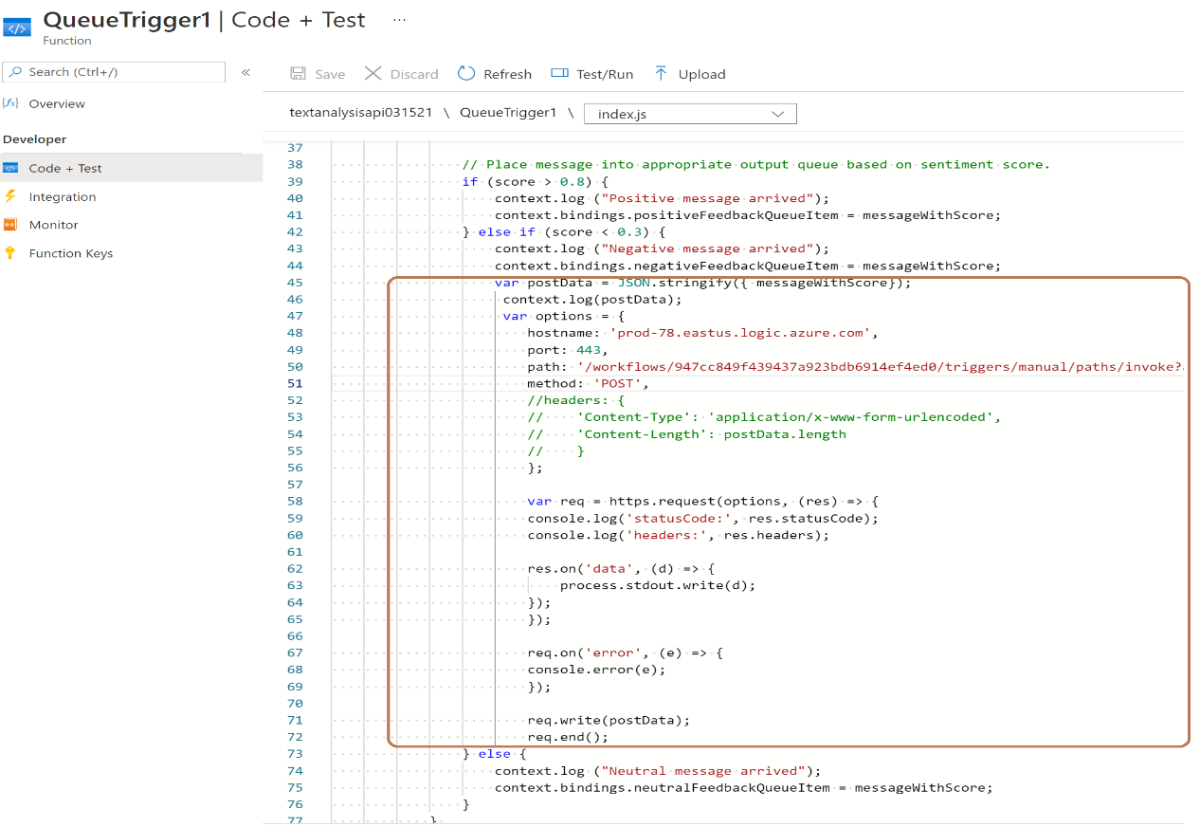

**Code:**

Replace the hostname and the path parameters using the information from your logic app HTTP POST method.

var postData = JSON.stringify({ messageWithScore});

var options = {

hostname: 'prod-78.eastus.logic.azure.com',

port: 443,

path: '/workflows/947cc849f439437a923bdb6914ef4ed0/triggers/manual/paths/invoke?api-version=2016-10-01&sp=%2Ftriggers%2Fmanual%2Frun&sv=1.0&sig=ymIutpGGLYrRxuocT1hvGqxB-uyAEjQJCQ_DKNM_s3c',

method: 'POST',

};

var req = https.request(options, (res) => {

console.log('statusCode:', res.statusCode);

console.log('headers:', res.headers);

res.on('data', (d) => {

process.stdout.write(d);

});

});

req.on('error', (e) => {

console.error(e);

});

req.write(postData);

req.end();